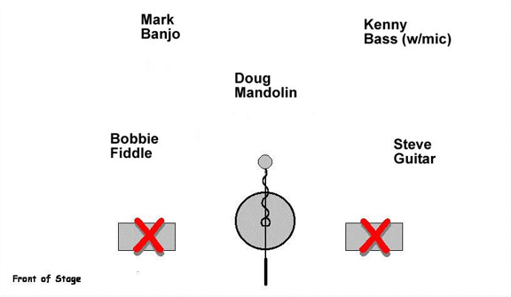

Our stage show focuses on a CLEAN STAGE with the band members performing around one Mic for Vocal and instrumental sound reinforcement. All other mic stands should be moved to the side whenever possible.

When we can’t get enough bass level through the primary mic, we like to use a clip on type condenser Microphone on the Bass. (SM35 provided by Band.)

High Plains Tradition uses NO MONITORS while performing.

High Plains Tradition will supply primary Microphone. (Audix SCX25)

All Microphones are condenser microphones, therefore phantom power will be supplied by Sound Crew. If phantom power in not available, please notify High Plains Tradition so we can make arrangements to bring portable phantom power.

